PLSQL_Exercise-1
Control Structures
Scenario-1 :-
Program:
SET SERVEROUTPUT ON;
DECLARE
TYPE Customer IS RECORD (
id NUMBER,age NUMBER,interest_rate NUMBER
);
TYPE CustomerList is table of Customer INDEX by PLS_INTEGER;
customers CustomerList;
BEGIN
customers(1) := Customer(101, 65, 8.5);
customers(2) := Customer(102, 45, 7.2);
customers(3) := Customer(103, 70, 9.0);
for i in customers.FIRST .. customers.LAST LOOP
IF customers(i).age > 60 THEN
customers(i).interest_rate := customers(i).interest_rate - 1;
DBMS_OUTPUT.PUT_LINE('Customer ' || customers(i).id || ' is eligible. New rate: ' || customers(i).interest_rate || '%');
ELSE
DBMS_OUTPUT.PUT_LINE('Customer ' || customers(i).id || ' is not eligible. Rate: ' || customers(i).interest_rate || '%');
END IF;
END LOOP;
END;
/
Output:
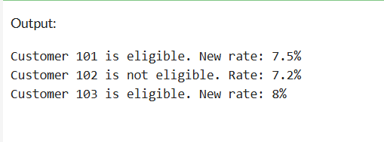
Scenario-2 :-
Program:
SET SERVEROUTPUT ON;
DECLARE
TYPE Customer IS RECORD (
id NUMBER, balance NUMBER,is_vip BOOLEAN
);
TYPE CustomerList is table of Customer INDEX BY PLS_INTEGER;
customers CustomerList;
BEGIN
customers(1) := Customer(201, 9500, FALSE);
customers(2) := Customer(202, 12000, FALSE);
customers(3) := Customer(203, 10500, FALSE);
for i in customers.FIRST .. customers.LAST LOOP
IF customers(i).balance > 10000 THEN
customers(i).is_vip := TRUE;
DBMS_OUTPUT.PUT_LINE('Customer ' || customers(i).id || ' promoted to VIP.');
ELSE
DBMS_OUTPUT.PUT_LINE('Customer ' || customers(i).id || ' is NOT a VIP.');
END IF;
END LOOP;
END;
/
Output:
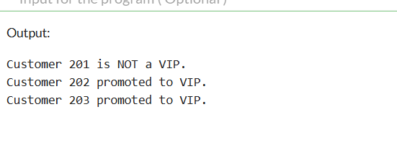

Scenario-3 :-
Program:
SET SERVEROUTPUT ON;
DECLARE
TYPE Loan IS RECORD (
customer_id NUMBER,
customer_name VARCHAR2(50),
due_date DATE
);
TYPE LoanList is table of Loan INDEX by PLS_INTEGER;
loans LoanList;
BEGIN
loans(1) := Loan(301, 'Ankit', SYSDATE + 10);
loans(2) := Loan(302, 'Sandya', SYSDATE + 35);
loans(3) := Loan(303, 'Rahul', SYSDATE + 5);
for i in loans.FIRST .. loans.LAST LOOP
IF loans(i).due_date <= SYSDATE + 30 THEN
DBMS_OUTPUT.PUT_LINE('Reminder: Loan for ' || loans(i).customer_name || ' is due on ' || TO_CHAR(loans(i).due_date, 'DD-Mon-YYYY'));
END IF;
END LOOP;
END;
/

Output:
